Python Installation Steps

1. Go to <https://www.python.org/downloads/windows/>

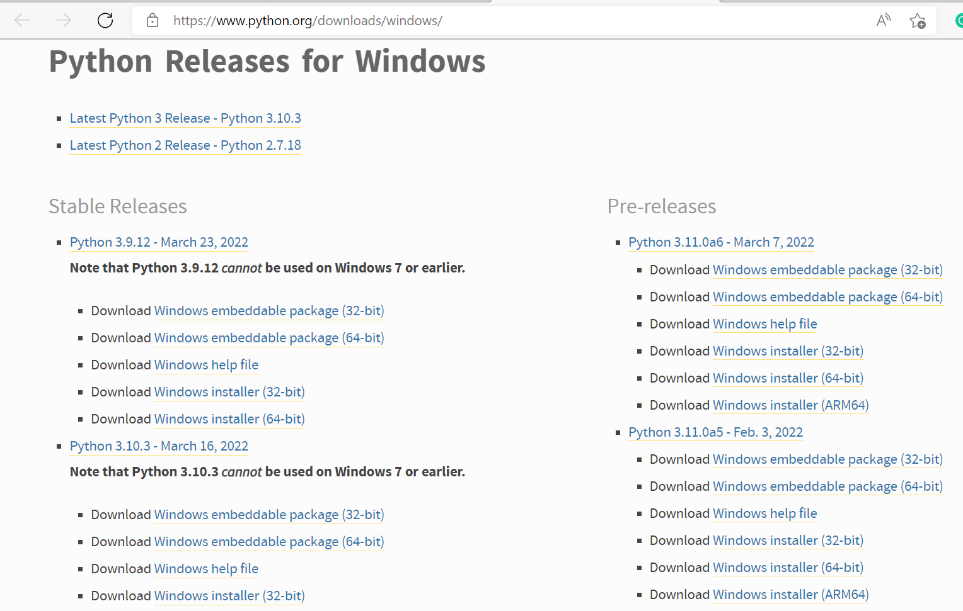

1. Click on “Download Windows installer (32-bit)
2. A file with the name python-3.10.3.exe will be downloaded. Open the file.
3. The following installation page will pop up.

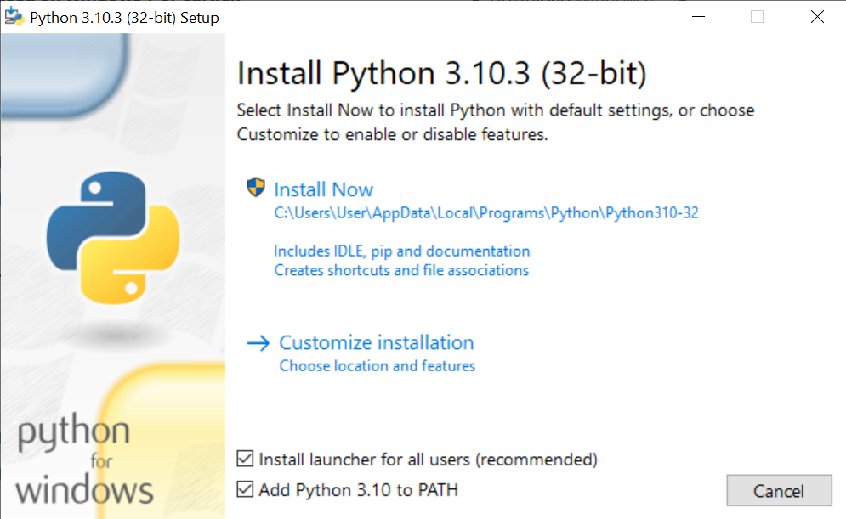

1. Don’t forget to tick both checkbox and click on Install Now

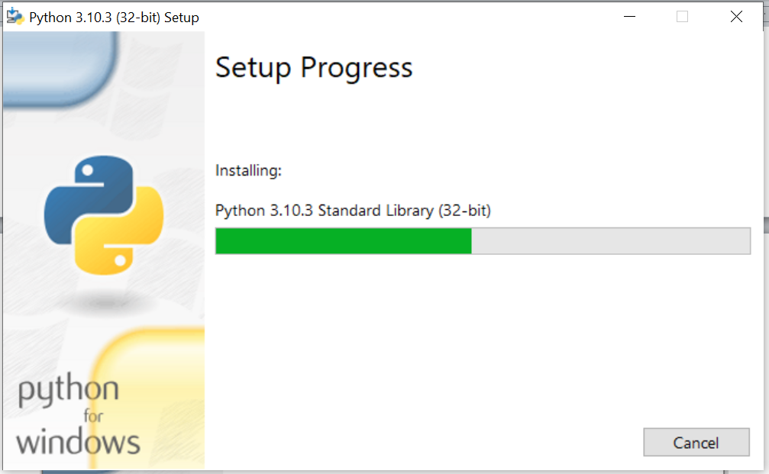

1. Wait for it to successfully install as shown below then click close

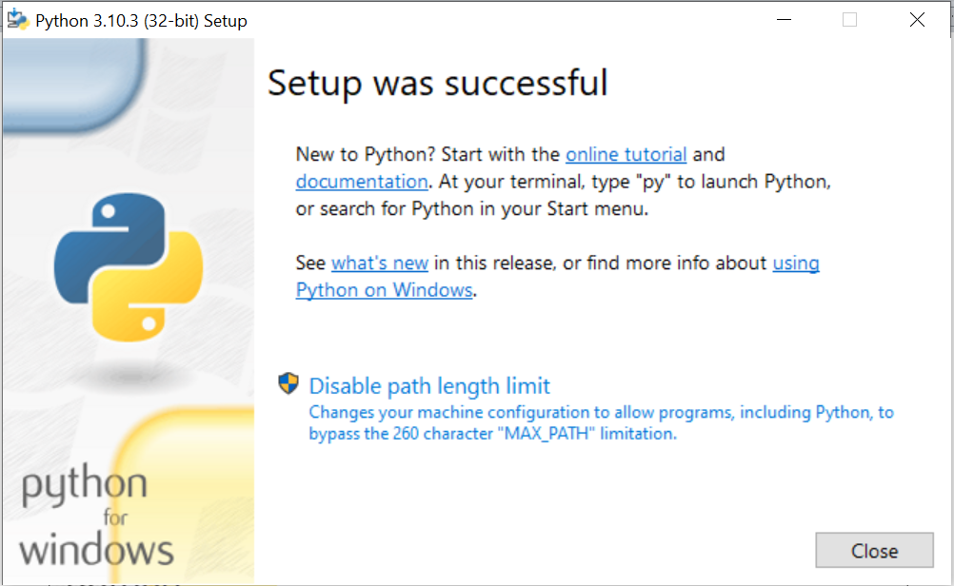

1. Now you need to install ‘numpy’
2. Open the ‘Run App’ then type “pip install numpy”. Click ‘OK’.

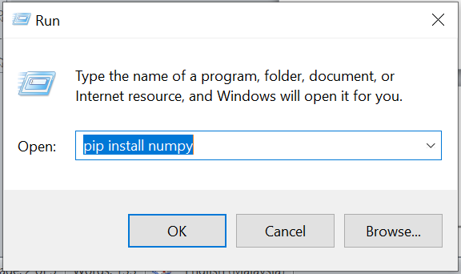

1. The following pop up screen will show.

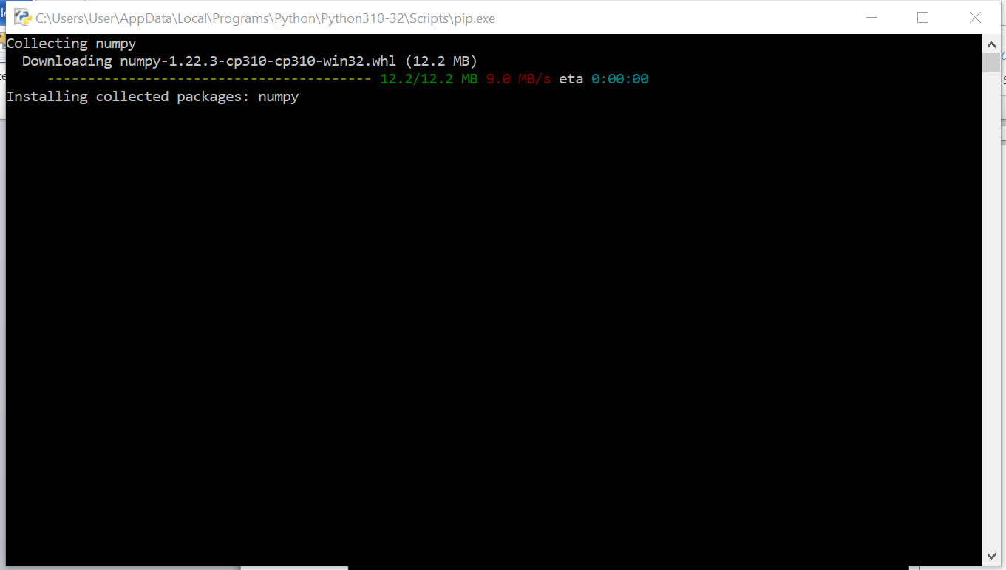

1. Install nltk by clicking on the Run App then type “pip install nltk”.

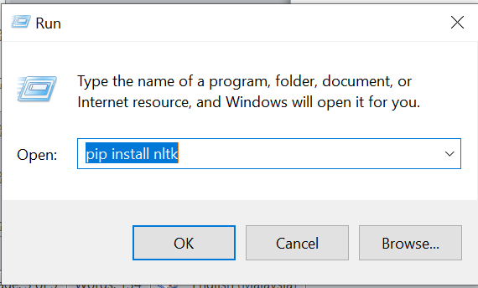

1. The following pop up screen will show.

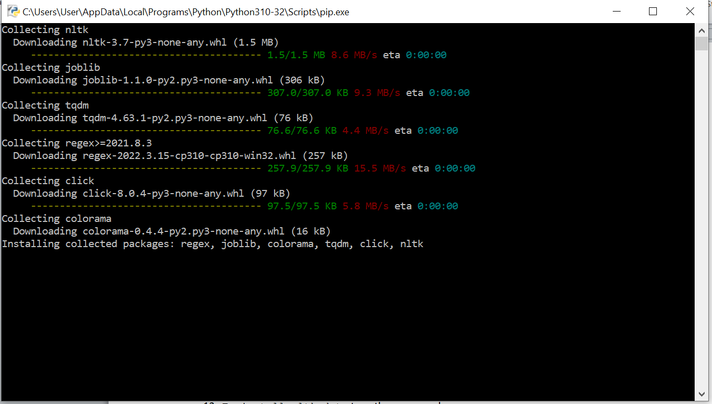

1. Test installation: Start> IDLE (Python 3.10 32 bit), then type import nltk
2. To install nltk data type the commands:

>>> import nltk

>>> nltk.download()

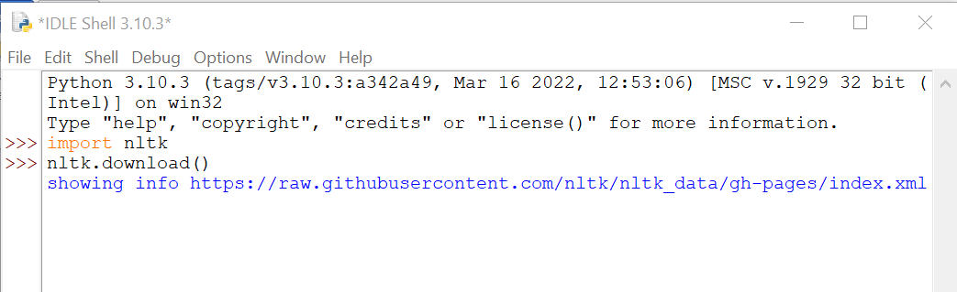

1. The nltk downloader screen will pop up:

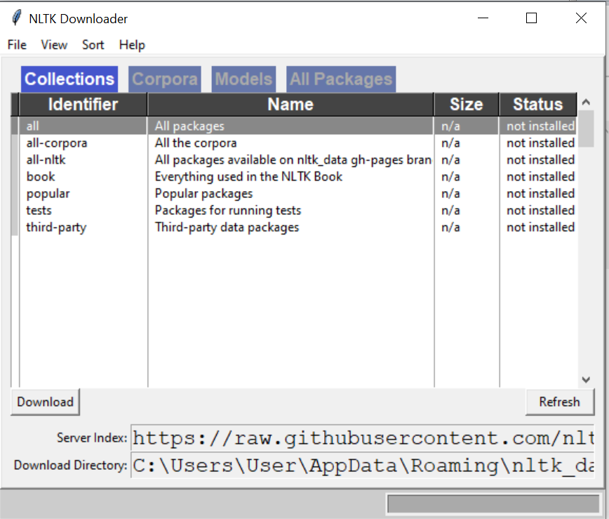

1. Screenshot during downloading:

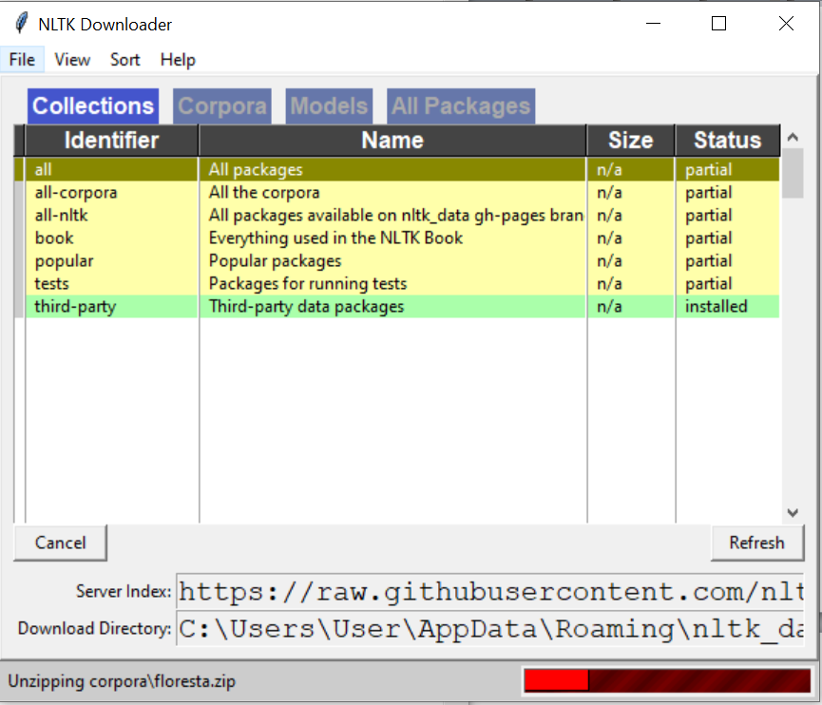

1. Screenshot after downloading:

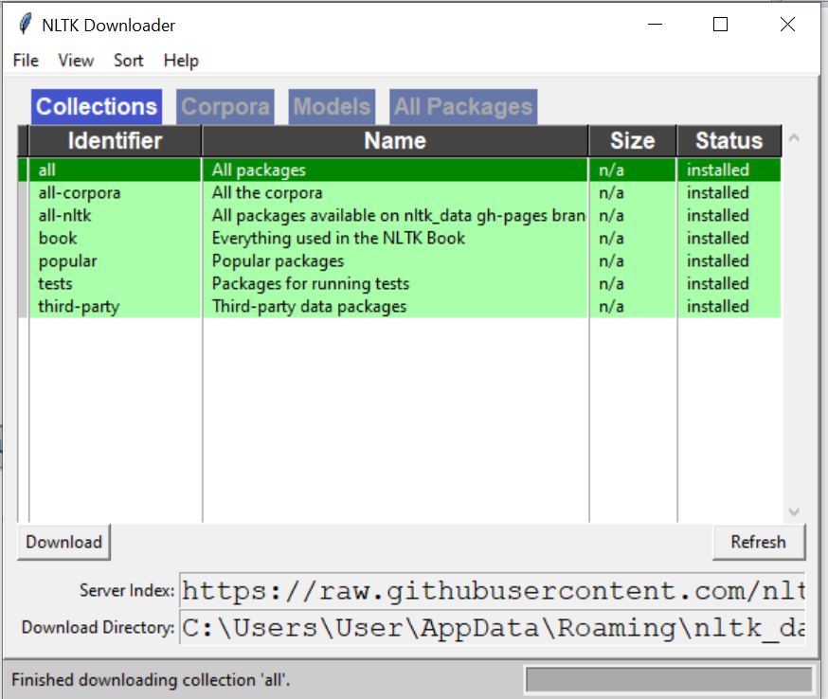

1. Close the popup window
2. The following confirmation will appear in your Python IDLE

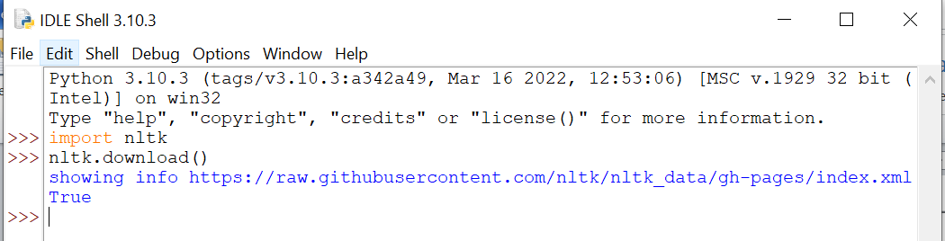

1. You are now ready to use Python NLTK